**BUS ARBITRATION**

 **KIET GROUP OF INSTITUTIONS GHAZIABAD** 

**(An ISO – 9001: 2008 Certified & 'A' Grade Accredited Institution by NAAC)**

**BUS ARBITRATION OR CONTENTION/ PRIORITY RESOLVING SCHEMES**

In Loosely coupled systems, all processors can use their local buses simultaneously. But the system bus can be used by only one module at a time. Hence there is a contest for the system bus. This is called bus arbitration. There are two approaches to Bus Arbitration

**A. Centralized Bus Arbitration:** Single bus arbiter performs the required arbitration.

**B. Distributed Bus Arbitration:** Devices participate in the selection of the next master.

To resolve the conflicts, we need to understand various bus arbitration schemes having different priority methods. These are explained below:

**A) Daisy Chaining Method**

* All bus masters use the same line for Bus Request.
* If the Bus Busy line is inactive, the Bus Controller gives the Bus Grant signal.
* Bus Grant signal is propagated serially through all masters starting from the nearest one.
* The bus master, which requires the system bus, stops this signal, activates the Bus Busy line, and takes control of the system bus.

**Let’s try to understand Daisy Chaining Method with the help of figure drawn below:**

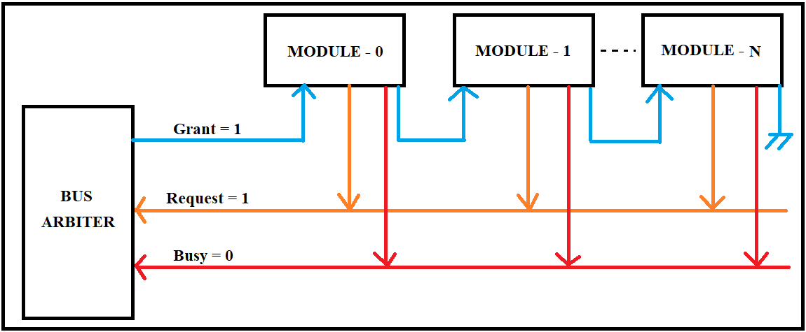

**Figure: Daisy Chaining**

**Table: Advantages of Daisy Chaining Method**

|  |
| --- |
| * The design is simple. |
| * The number of control lines is less. |
| * Also adding new bus masters is easy. |

 **KIET GROUP OF INSTITUTIONS GHAZIABAD** 

**(An ISO – 9001: 2008 Certified & 'A' Grade Accredited Institution by NAAC)**

**Table: Disadvantages of Daisy Chaining Method**

|  |
| --- |
| * The priority of bus masters is rigid and depends on the physical proximity of the bus masters with the bus arbiter i.e. The one nearest to the Bus Arbiter gets the highest priority. Therefore, it has **poor performance.** |
| * The bus is granted serially and hence a propagation delay is induced in the circuit. Therefore, it has poor **priority mechanism.** |
| * Failure of one of the devices may fail the entire system. Therefore, it has **poor reliability.** |

**Application of Daisy Chaining Method**

* **Daisy Chaining Method is very well suited for the smallest simplest network with very few computers e.g. 2 to 4 computers.**

 **KIET GROUP OF INSTITUTIONS GHAZIABAD** 

**(An ISO – 9001: 2008 Certified & 'A' Grade Accredited Institution by NAAC)**

**B) Polling Method**

* Here also all bus masters use the same line for Bus Requests.
* Here the controller generates a binary address for the master. E.g: To connect 8 bus masters we need 3 address lines (23= 8).
* In response to a Bus Request, the controller "polls" the bus masters by sending a sequence of bus master addresses on the address lines. Eg: 000, 010, 100, 011 etc.
* The selected master activates the Bus Busy line and takes control of the bus.

**Let’s try to understand Polling Method with the help of figure drawn below:**

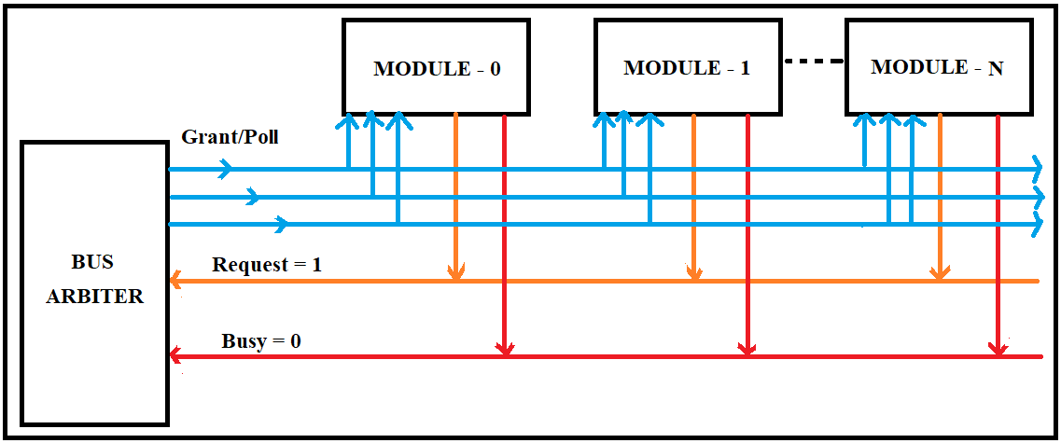

**Figure: Polling**

**Table: Advantages of Polling Method**

|  |
| --- |
| * This method is also quite simple. |
| * The priority is flexible and can easily be changed by altering the polling sequence. |
| * If one module fails, the entire system does not fail. |

**Table: Disadvantages of Polling Method**

|  |
| --- |
| * Adding more bus masters is difficult as it increases the number of address lines of the circuit. E.g: In the above circuit to add the 9th Bus Master we need 4 address lines. |

**Application of Polling Method**

* It is well suited for big networks which demand good reliability, decent priority scheme with controlled cost, though performance will not be the most important parameter for such networks.

 **KIET GROUP OF INSTITUTIONS GHAZIABAD** 

**(An ISO – 9001: 2008 Certified & 'A' Grade Accredited Institution by NAAC)**

**C) Independent Request Method**

* Here, all bus masters have their individual Bus Request and Bus Grant lines.
* The controller thus knows which master has requested, so the bus is granted to that master.
* Priorities of the masters are predefined so on simultaneous Bus Requests, the bus is granted based on the priority, provided the Bus Busy line is not active.
* The Controller consists of encoder and decoder logic for the priorities.

**Let’s try to understand Independent Request Method with the help of figure drawn below:**

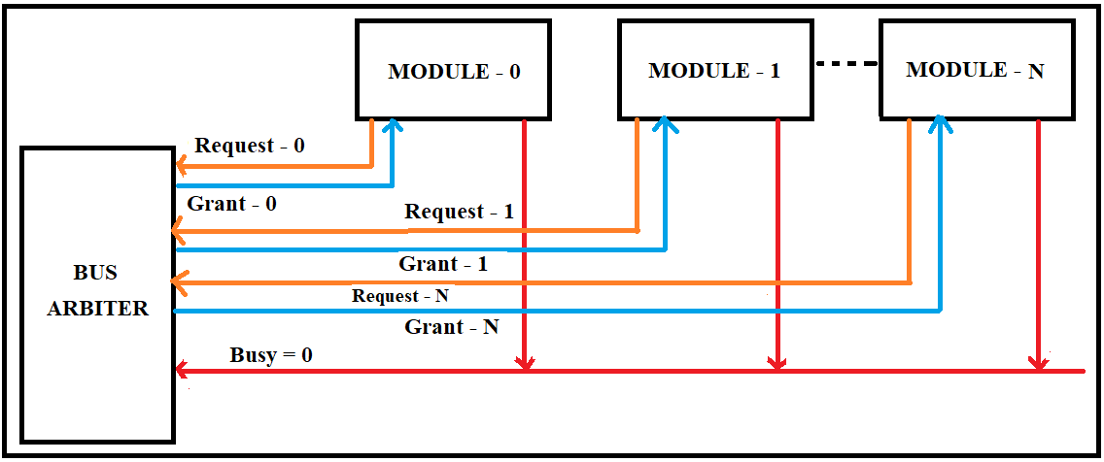

**Figure: Independent Request**

**Table: Advantages of Independent Request**

|  |
| --- |
| * Bus Arbitration is a fast and dynamic priority is also possible. |
| * The speed of Bus Arbitration is independent of the number of devices connected. |

**Table: Disadvantages of Independent Request**

|  |
| --- |
| * The number of control lines required is more (2n line required for n devices). |
| * Hardware cost is high as large nos. of control lines are required. |

**Application of Independent Request**

* It is well suited for big networks like in huge organizations where cost is not an issue but the performance is the key requirement.

 **KIET GROUP OF INSTITUTIONS GHAZIABAD** 

**(An ISO – 9001: 2008 Certified & 'A' Grade Accredited Institution by NAAC)**

**Comparison of Bus Arbitration Methods**

|  |  |  |  |
| --- | --- | --- | --- |
| **Differentiating Parameters** | **Daisy Chaining Method** | **Polling**  **Method** | **Independent Request**  **Method** |
| **Performance** | Poor | Better performance than Daisy Chaining  Method. | Better performance  than Polling  Method. |
| **Reliability** | Poor | Good | Good |
| **Priority Mechanism** | Poor | Good | Good |
| **Addition of New Device** | Adding a new device to the network is easy. | Adding a new device in the network means disturbing the entire existing system. | Adding new devices in the network makes the circuit more complex. |
| **Number of Total Lines Required to Build a Network e.g. 1024 computers** | Small  (Total= 3) | Moderate  (Total= 12) | Large  (Total= 2049) |
| **Applications** | Used in the smallest simplest network having two to four computers. | Used in a large network where performance is not much required as well as where cost needs to be under control. | Used in those organizations, where cost is not the issue but good performance is the key requirement. E.g. In banks |

* **In the modern technological era, we need the Hybrid of Bus Arbitration Methods. For example, polling and independent requests when putting together, give superb best features of both methods but yes, it makes the system structure more complex.**